Week 3 Review

Week 3 started out very interesting for me in terms of research. I started focussing heavily on urban farming, I found it to be a very exciting niche that has also been quite busy lately. Technology and IoT could be very applicable in this area as it is changing and growing rapidly. There are some really interesting innovations being done in Urban Farming:

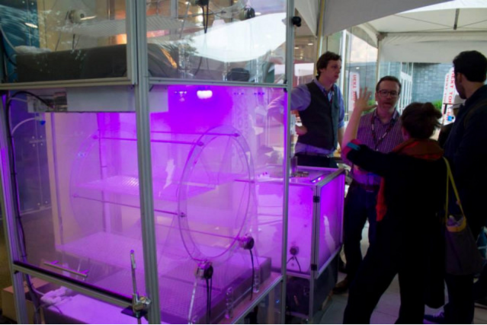

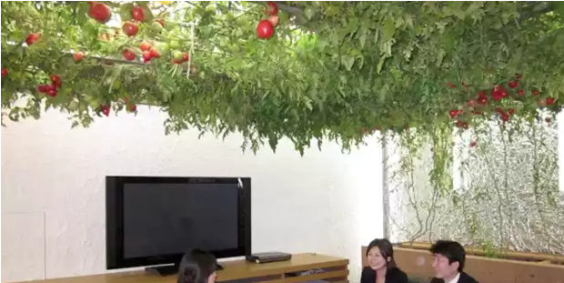

<http://www.digitaltrends.com/home/glowing-indoor-garden-boxes-future-urban-agriculture/>

One thing that really caught my attention about Urban farming was the many tangible and intangible benefits involved. The more obvious benefits include easier access to healthy food. Communities with Urban Farms tend to eat healthier, as the food becomes more affordable and easier to get. There are also economic benefits, people could actually earn a good profit out of farming in their own homes. They are also more sustainable, as they are less reliant on environmental and seasonal factors. Urban farms make a better use of resources and are better for the environment, there is less wastage especially with an indoors set up. Along with so many other little benefits that are not as obvious, such as providing refuge for bees and other small fauna.

The biggest intangible benefit was the social aspect of urban farming. The activity of farming in your own home and being part of a farming community is great for mental health, which is a growing concern in developed cities. It also increases social interaction and creates bonds through the process of sharing and discovering things with members of your community. People could begin growing food in their own homes, buy food from others in their neighbourhood or even donate food to people who may have need for it.

This leads into another great benefit of Urban Farming. When I was sharing my idea with professors and PHD students at the end of week 2, one of the students told me about Food Banks. I was not familiar with them before but I looked into them and found they are very significant in UK. They provide help to a lot of people, there were even Food Banks close to me here in Dundee. I thought this could be something that would tie in nicely with the Urban Farming concept. Along with buying and selling the food could also be given to food banks and perhaps a system could be set up that incorporated food banks into the community of Urban Farmers.

I discussed my Idea with Martin in our tutorial, and I also discussed another idea I had of making a device using GPS that could detect the proximity of certain locations near you. For example it could tell you if you were close to some restaurants, cafes, bars, parks etc. so you didn’t have to go through the process of searching through your phone every time you travelled to a place. I thought this was a cool concept but It was not as well researched and I was reluctant to change directions at this stage. However, martin suggested I could incorporate this idea with my Urban Farms idea so the device could detect the proximity of farms close to you. I really liked this idea, and I began thinking of ways I could merge these two together. In the rest of Week 3 I decided on making a product related to urban farms and started sketching first drafts for what I wanted to make.